Prosperity Prognosticator: Machine Learning for Startup Success Prediction
1. INTRODUCTION
1.1 Project Overview
This project, titled “Prosperity Prognosticator: Machine Learning for Startup Success Prediction,” is developed as part of the SmartBridge Virtual Internship Program. The objective of this project is to predict the success outcome of startups using business, financial, and operational parameters through machine learning techniques.
In the modern entrepreneurial ecosystem, making informed investment and business decisions is crucial for long-term sustainability and economic growth. Startups face high uncertainty, and their success depends on multiple factors such as funding amount, industry category, number of funding rounds, market conditions, and management structure. Accurately predicting startup success is challenging due to the complex and dynamic nature of business environments.
This project addresses this challenge by applying artificial intelligence to analyze historical startup data and identify patterns that influence business outcomes. By leveraging machine learning algorithms, the system predicts whether a startup is likely to be Acquired, Closed, or Continue Operating, helping investors, entrepreneurs, and analysts make data-driven decisions.

1.2 Purpose
The main purpose of this project is to apply theoretical knowledge of artificial intelligence and machine learning to develop a practical solution for predicting startup success based on business, financial, and operational parameters. The project enables understanding of data preprocessing, feature engineering, machine learning model training, and integration of the prediction model into a functional web application using Python and related technologies.
The project also provides hands-on experience in working with real-world startup datasets and building an end-to-end predictive system. It enhances analytical thinking, decision-making capability, and technical skills in machine learning, data analysis, and application development for business intelligence and investment forecasting.

2. IDEATION PHASE
2.1 Problem Statement
In the modern entrepreneurial and investment ecosystem, predicting startup success has become increasingly important. However, startup outcomes are influenced by multiple dynamic factors such as funding amount, number of funding rounds, industry category, market competition, and management efficiency, making business success uncertain and difficult to predict accurately.
Most existing evaluation methods rely on manual analysis, intuition, or basic financial indicators, which may be subjective, time-consuming, and not suitable for data-driven decision-making. Inaccurate prediction of startup success can lead to poor investment decisions, financial losses, and inefficient allocation of resources.
Therefore, there is a strong need for a simple, accurate, and AI-based startup success prediction system that can analyze historical startup data and forecast business outcomes (Acquired, Closed, or Operating) to support smart investment planning and strategic decision-making.

2.2 Empathy Map Canvas
The Empathy Map Canvas is used to understand the users, their challenges, concerns, and expectations in evaluating startup performance. This helps in designing a user-centric startup prediction solution.

What the User Thinks
• Wants to know whether a startup will succeed or fail
• Expects accurate prediction to reduce investment risk

What the User Feels
• Uncertain about startup future performance
• Confident when data-driven prediction supports decisions

What the User Says
• “Startup success is difficult to predict.”
• “I need reliable insights before investing.”

What the User Does
• Analyzes financial reports and funding history manually
• Uses past experience or basic metrics for evaluation

User Pain Points
• High uncertainty in startup investments
• Lack of accurate forecasting tools
• Risk of financial loss due to poor prediction

User Needs
• Accurate AI-based startup success prediction
• Simple and reliable web-based application
• Clear probability score and outcome explanation
2.3 Brainstorming
During the brainstorming phase, different approaches were discussed to solve the challenge of predicting startup success. These included traditional statistical analysis methods, financial ratio–based evaluation techniques, rule-based decision systems, and machine learning–based prediction models using historical startup and investment data.
After evaluating all options, the machine learning–based approach was selected because it provides higher prediction accuracy, adaptability to complex business patterns, and scalability for analyzing large startup datasets. Machine learning models can learn from historical funding, operational, and outcome data and improve prediction performance over time, making them suitable for real-world investment analysis and business intelligence applications.

3. REQUIREMENT ANALYSIS
The Customer Journey Map explains the sequence of steps followed by the user while interacting with the startup success prediction system. It helps in understanding how the user experiences the application from data input to prediction output.
The journey begins when the user opens the application and logs in to the system. The user then enters startup-related parameters such as funding amount, number of funding rounds, industry category, number of founders, and other relevant business details.
The system receives the input data and processes it using the trained machine learning prediction model. After processing, the predicted startup outcome (Acquired, Closed, or Operating) along with the probability score is generated and displayed to the user.
This flow ensures smooth interaction, accurate prediction, and easy usability for investors, entrepreneurs, and business analysts, supporting informed decision-making and reducing investment risk
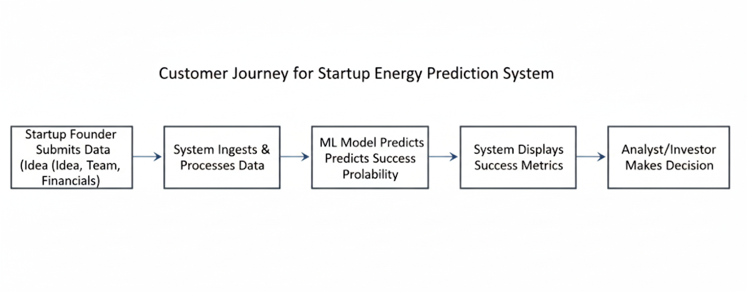
3.2 Solution Requirements
This section describes the functional and non-functional requirements of the proposed Startup Success Prediction System.

Functional Requirements
• The system should allow the user to enter startup-related input parameters (e.g., funding amount, number of funding rounds, industry category, number of founders, operational years, and other business metrics).
• The system should validate the user inputs before processing.
• The system should preprocess the input data (encoding, scaling, handling missing values) for prediction.
• The system should use the trained Machine Learning model to predict startup success outcome (Acquired / Closed / Operating).
• The system should display the predicted startup outcome along with probability score to the user.
• The system should handle invalid inputs and errors properly.
• The system should allow users to select predefined categories (e.g., industry type) from dropdown lists.
• The system should store prediction records in the database (if database integration is enabled).
• The system should provide prediction results instantly after submission.

Non-Functional Requirements
• The system should have a simple, user-friendly interface that is easy to navigate and understand.
• The system should provide fast response time and generate predictions within a few seconds.
• The system should consistently provide accurate and dependable prediction results.
• The system should ensure secure handling of user inputs and protect sensitive business data.
• The system should be accessible and operational whenever users need to perform predictions.
• The system should be capable of handling multiple users without performance degradation.
• The system should be designed in a modular way to allow easy updates, model retraining, and feature enhancements.
3.3 Data Flow Diagram
The Data Flow Diagram (DFD) explains how data moves within the system during the startup success prediction process.
The user provides startup-related input parameters through the user interface. The input data is sent to the preprocessing module, where it is validated, cleaned, encoded, and scaled as required. The processed data is then forwarded to the trained Machine Learning prediction model. Finally, the predicted startup outcome (Acquired / Closed / Operating) along with the probability score is sent back to the user interface for display.
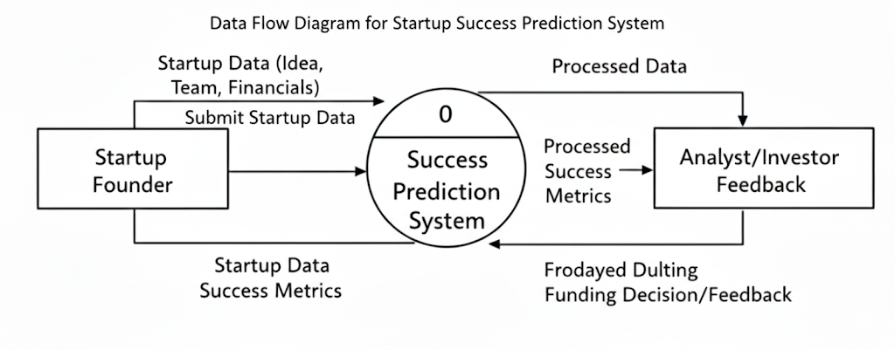
3.4 Technology Stack
The following technologies are used in the development of this project:
• Programming Language: Python
• Framework: Flask
• Machine Learning Library: Scikit-learn (for building and training the prediction model)
• Data Processing Libraries: Pandas, NumPy
• Model Storage: Pickle (.pkl file for saving the trained model)
• Frontend Technologies: HTML, CSS
• Development Tools: VS Code, Git, GitHub

4. PROJECT DESIGN
4.1 Problem–Solution Fit
The proposed Startup Success Prediction System effectively addresses the challenge of uncertain startup outcomes by using Machine Learning techniques to predict business success based on input parameters.
The system collects relevant startup and financial data, preprocesses it, and applies a trained ML model to generate accurate outcome predictions. This automated solution reduces manual analysis, improves prediction accuracy, supports better investment planning, and enhances strategic decision-making.
The system is suitable for real-world applications such as venture capital analysis, investment risk assessment, and business intelligence systems.

4.2 Proposed Solution
The proposed solution is a Machine Learning–based web application that enables users to predict startup success outcomes based on business and financial parameters.
The working of the system is described below:
• The user provides startup-related input parameters such as funding amount, number of funding rounds, industry category, number of founders, and operational details.
• The system preprocesses and validates the input data.
• The trained Machine Learning model processes the data to predict startup outcome (Acquired / Closed / Operating).
• The predicted result along with the probability score is generated and displayed to the user through the web interface.
The system is designed to be simple, fast, and user-friendly, ensuring ease of use for investors, entrepreneurs, analysts, and business decision-makers.
4.3 Solution Architecture
The solution architecture explains the overall structure of the system and how different components interact with each other.
The architecture consists of the following components:
• User Interface: Accepts startup-related input parameters (such as funding amount, number of funding rounds, industry category, number of founders, operational details, etc.) from the user and displays the predicted startup outcome along with the probability score.
• Preprocessing Module: Validates, cleans, encodes, and formats the input data before sending it to the prediction model.
• Machine Learning Prediction Model: Processes the preprocessed data and predicts the startup success outcome (Acquired / Closed / Operating) using a trained classification algorithm.
• Output Module: Displays the predicted startup result and probability score clearly to the user through the web interface.
These components work together in a sequential manner to ensure accurate, fast, and reliable startup success prediction.
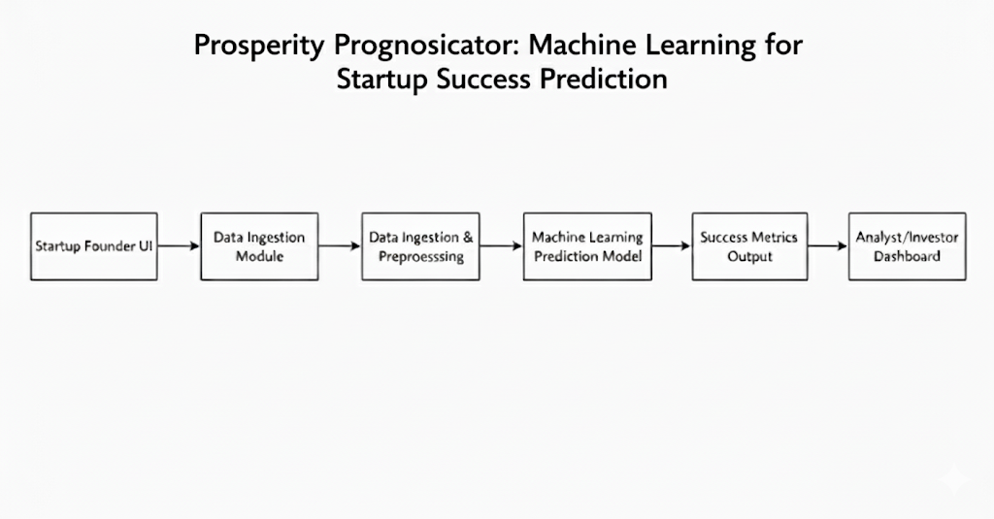
5. PROJECT PLANNING AND SCHEDULING
Project planning plays an important role in completing the project in a systematic and organized manner. The Startup Success Prediction System was planned and executed in multiple phases to ensure smooth development and timely completion.
The planning of the project was carried out in the following stages:
• Requirement Analysis: Understanding the problem of predicting startup outcomes, defining project objectives, and identifying user requirements such as input parameters (funding amount, funding rounds, industry, number of founders, etc.), prediction accuracy, and system usability.
• Design Phase: Designing the system architecture and defining the interaction between components such as the user interface, preprocessing module, machine learning model, and output module.
• Development Phase: Implementing the application using Python and Flask, developing the machine learning classification model using Scikit-learn, and integrating the trained model with the web interface.
• Testing Phase: Testing the system for correct predictions, input validation, response time, and overall user interaction to ensure reliability and accuracy. Model performance metrics such as accuracy score, confusion matrix, and classification report were evaluated.
• Deployment Phase: Running the application locally, verifying end-to-end functionality, and preparing the system for future enhancements such as cloud deployment or database integration.
This phased approach helped in managing the project efficiently, ensuring structured development, and reducing errors during implementation.

5.2 Project Scheduling
The project schedule was planned to complete all activities within a total duration of 20 days, as per the SmartBridge internship timeline. Each phase was carefully allocated time to ensure proper implementation, testing, and documentation of the project.
The scheduling of the Startup Success Prediction System project is shown below:
Phase | Activity | Duration
Phase 1 | Requirement Analysis | 3 Days
Phase 2 | System Design | 3 Days
Phase 3 | Application Development | 7 Days
Phase 4 | Testing and Debugging | 4 Days
Phase 5 | Deployment and Documentation | 3 Days

6. FUNCTIONAL AND PERFORMANCE TESTING
Functional testing is performed to verify that all features of the Startup Success Prediction System work according to the specified requirements.
The following functional tests were conducted:
• Verification of input functionality: Ensuring that the system correctly accepts startup-related input parameters such as funding amount, number of funding rounds, industry category, number of founders, and other operational details.
• Validation of input data: Checking that the system properly validates inputs, handles missing or invalid values, and restricts incorrect data formats.
• Verification of model integration: Ensuring correct integration between the web application and the trained Machine Learning classification model.
• Verification of prediction output display: Checking that the predicted startup outcome (e.g., Acquired, Closed, Operating) and probability score are correctly generated and displayed to the user.
• Error handling validation: Ensuring the system properly handles runtime errors and provides meaningful feedback messages to users.
All functional requirements were tested successfully, and the system performed as expected.

6.2 Performance Testing
Performance testing is conducted to evaluate the response time, efficiency, and stability of the Startup Success Prediction System.
The system was tested for:
• Response Time of Prediction Generation: Measuring the time taken by the system to process startup input parameters and generate predictions.
• Stability During Multiple Requests: Testing the system’s ability to handle multiple prediction requests simultaneously without crashing or slowing down significantly.
• Smooth Interaction Between Web Interface and ML Model: Ensuring seamless communication between the Flask web application and the trained Machine Learning classification model.
• System Resource Usage: Monitoring CPU and memory usage during prediction to ensure efficient and optimized performance.
The results show that the system generates predictions with minimal delay and provides a smooth and reliable user experience under normal usage condition
7. RESULTS
The Startup Success Prediction System was successfully developed and tested using Python, Flask, and Machine Learning techniques. The system provides accurate and fast predictions of startup outcomes based on user-entered business and funding parameters.
The application interface consists of:
• Input fields for entering startup-related parameters such as funding amount, number of funding rounds, industry category, number of founders, and operational details
• A Predict button to generate the startup success prediction
• A display section showing the predicted startup outcome (Acquired / Closed / Operating) along with the probability score
When the user enters the required input parameters and clicks the Predict button, the application sends the data to the backend. The preprocessing module validates, cleans, and encodes the data before passing it to the trained Machine Learning classification model.
The model processes the input features and returns the predicted startup outcome with its probability, which is displayed instantly on the web interface.
The results confirm that the system performs as expected and meets all the functional requirements defined in the project. The predictions are generated quickly with minimal delay, ensuring a smooth and user-friendly experience.

7.2 Output Screenshots
The output screenshots demonstrate the working of the Startup Success Prediction System. The screenshots show:
• User-entered input values such as funding amount, funding rounds, industry type, and number of founders
• Validation messages for incorrect or missing inputs
• The predicted startup outcome displayed after clicking the Predict button
• The probability score indicating the likelihood of each possible outcome
These screenshots confirm that the system correctly accepts user inputs, processes the data through the Machine Learning model, and displays accurate classification results through the web interface.
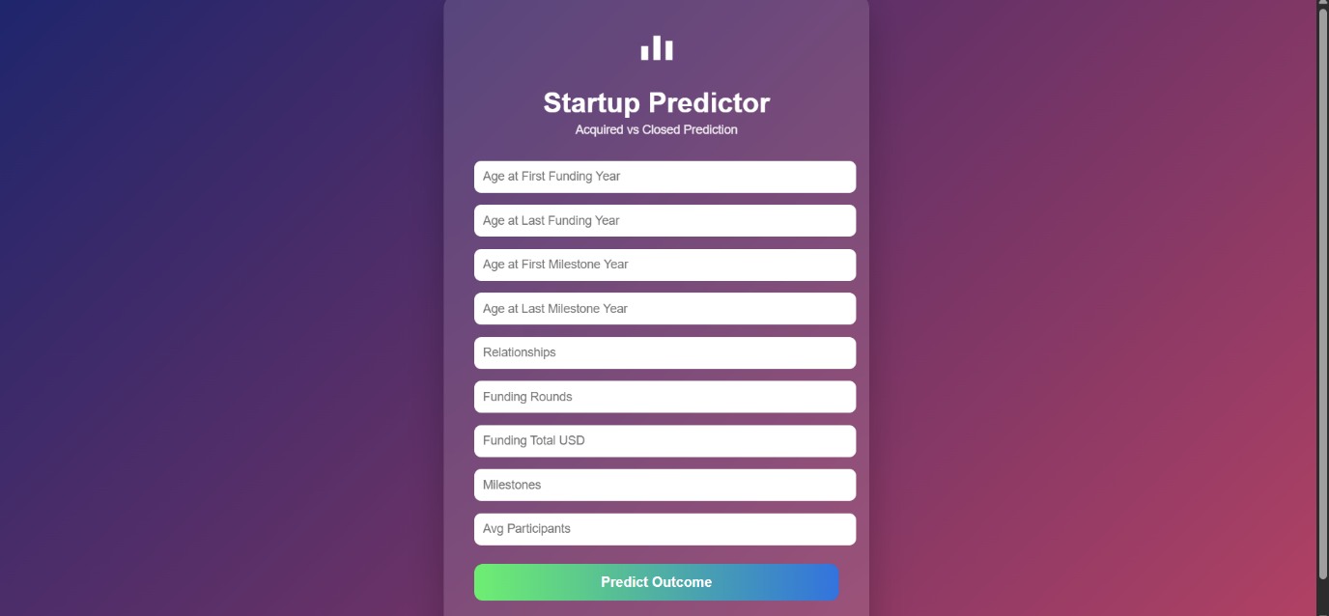

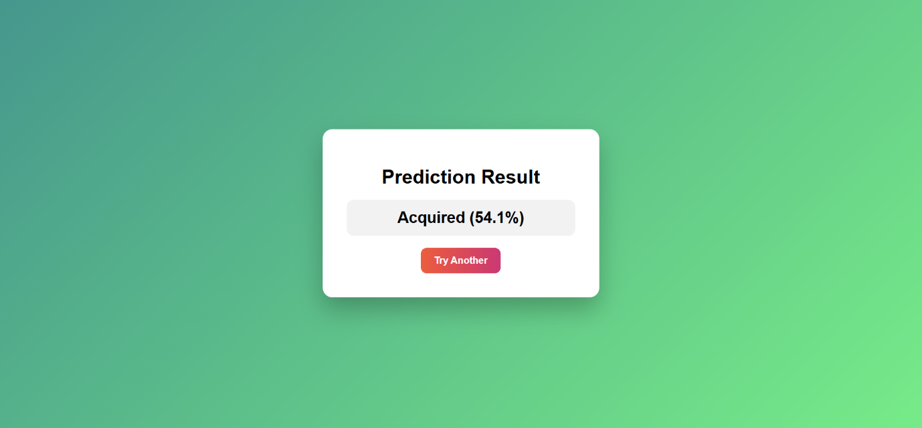

8. ADVANTAGES AND DISADVANTAGES

8.1 Advantages
The Startup Success Prediction System provides several advantages that make it effective and practical for real-world applications:
• Easy-to-use and user-friendly web interface
• Fast prediction of startup outcomes with minimal response time
• Accurate classification based on funding and business-related parameters
• Web-based application with simple deployment
• Lightweight and scalable system design
• Helps investors and entrepreneurs in decision-making
• Useful for students, researchers, and business analysts
• Provides probability scores for better interpretation of results

8.2 Disadvantages
Despite its advantages, the Startup Success Prediction System has a few limitations:
• Prediction accuracy depends on the quality and quantity of historical startup data
• The current model may not consider qualitative factors such as leadership skills, market trends, or economic conditions
• Requires proper preprocessing for accurate predictions
• Performance may vary depending on server configuration and system resources
• The model may need periodic retraining to maintain accuracy with new data

9. CONCLUSION
The Startup Success Prediction System successfully demonstrates the application of Machine Learning techniques to predict startup outcomes based on funding and operational parameters. The project provides an efficient and user-friendly solution for analyzing startup success probability using a web-based interface built with Python and Flask.
The application delivers fast and reliable predictions by processing inputs such as funding amount, number of funding rounds, industry category, and number of founders. The system applies a trained classification model to generate outcome predictions along with probability scores, helping users understand the likelihood of success or failure.
With a simple interface and structured backend integration, the project ensures smooth interaction between the user and the prediction model. The system can assist investors, entrepreneurs, students, and researchers in evaluating startup potential.
Overall, the project meets all defined objectives and showcases the practical implementation of machine learning in business analytics applications. It serves as a strong demonstration of technical skills and real-world problem-solving capability, making it suitable for academic and internship evaluation.

10. FUTURE SCOPE
The Startup Success Prediction System can be further enhanced in the future to improve functionality, accuracy, and scalability. Some possible future enhancements include:
• Integration with real-time business and financial data sources
• Deployment on cloud platforms for global access and scalability
• Incorporation of advanced Machine Learning or Deep Learning models to improve prediction accuracy
• Inclusion of additional factors such as market trends, competitor analysis, and founder background
• Development of a mobile application version for wider accessibility
• Implementation of interactive dashboards and data visualization for detailed analytics
• Expansion to support investor portfolio risk analysis
These enhancements can make the system more intelligent, scalable, and suitable for real-world investment and business decision-making applications.

11. APPENDIX
The complete source code of the project Startup Success Prediction System is maintained using GitHub for version control. The repository contains all application files, including:
• Backend application files (Flask – app.py)
• Frontend templates (index.html, predict.html)
• CSS styling files
• Machine Learning model file (model.pkl)
• Configuration and dependency files
• Project documentation
The version control system helps in tracking changes, managing updates, and maintaining proper documentation throughout the development process.
The repository provides all the necessary files required to understand, execute, and further enhance the project.
GitHub Repository Link:

Repository Contents
The GitHub repository for the Startup Success Prediction System contains the following files:
• app.py – Main Flask application file that handles routing, user inputs, and prediction logic
• templates/index.html – Homepage of the application
• templates/predict.html – Prediction page for entering startup parameters and viewing results
• static/style.css – CSS file for UI styling
• model.pkl – Trained Machine Learning model file
• requirements.txt – List of required Python dependencies
• .gitignore – Excludes unnecessary or sensitive files from version control
• README.md – Project description, setup instructions, and usage guidelines
Using GitHub helped in maintaining proper version control, tracking changes efficiently, and following professional software development practices throughout the project lifecycle.

11.2 Security Implementation
The Startup Success Prediction System was developed with proper security considerations to ensure safe handling of application data and system resources.
The following secure practices were implemented:
• Sensitive configuration details (such as secret keys, if used) are stored using environment variables
• A .env file is used to securely manage configuration values
• The .env file is excluded from GitHub using .gitignore to prevent exposure of sensitive data
• No secret keys or confidential information are hardcoded in the source code
• Input validation is implemented to prevent invalid or malicious user inputs
These practices ensure secure handling of sensitive information, protect the application from common vulnerabilities, and maintain professional software development standards.

11.3 Project Demo
A working demo of the Startup Success Prediction System was recorded to demonstrate the functionality and output of the application.
Project Demo Video Link:
The demo video showcases:
• User entering startup-related input parameters such as funding amount, funding rounds, industry type, and number of founders
• Clicking the “Predict” button to generate the startup outcome
• Display of predicted startup status (Acquired / Closed / Operating)
• Display of probability scores for better decision analysis
• Final output displayed clearly on the web interface
The demo confirms that the system works as expected and successfully performs startup success prediction with a smooth and user-friendly interface.

11.4 Team Details
• Internship Program: SmartBridge Virtual Internship
• Project Start Date: 29 January 2026
• Team ID: LTVIP2026TMIDS84120
• Team Size: 4
Team Leader:
Parasa Lakshmi Sruthi
Team Members:
• Vundamatla Vishnu Manikanta
• Rankireddy Durga Bhima Shankar
• Vamsi Odugu

11.5 References
The following resources were referred to during the development of this project:
• Python Programming Language
• Flask Framework
• Scikit-learn Library
• NumPy and Pandas Libraries
• Machine Learning Documentation and Online Tutorials

